AI in Healthcare Specialization
What you'll learn
- Identify problems healthcare providers face that machine learning can solve
- Analyze how AI affects patient care safety, quality, and research
- Relate AI to the science, practice, and business of medicine
- Apply the building blocks of AI to help you innovate and understand emerging technologies
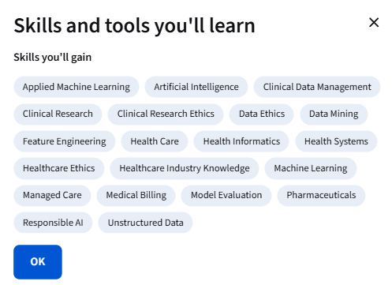
Specialization - 5 course series
Artificial intelligence (AI) has transformed industries around the world, and has the potential to radically alter the field of healthcare. Imagine being able to analyze data on patient visits to the clinic, medications prescribed, lab tests, and procedures performed, as well as data outside the health system -- such as social media, purchases made using credit cards, census records, Internet search activity logs that contain valuable health information, and you’ll get a sense of how AI could transform patient care and diagnoses.
In this specialization, we'll discuss the current and future applications of AI in healthcare with the goal of learning to bring AI technologies into the clinic safely and ethically.
This specialization is designed for both healthcare providers and computer science professionals, offering insights to facilitate collaboration between the disciplines.
CME Accreditation
The Stanford University School of Medicine is accredited by the Accreditation Council for Continuing Medical Education (ACCME) to provide continuing medical education for physicians. View the full CME accreditation information on the individual course FAQ page.
Applied Learning Project
The final course will consist of a capstone project that will take you on a guided tour exploring all the concepts we have covered in the different classes. This will be a hands-on experience following a patient's journey from the lens of the data, using a unique dataset created for this specialization.We will review how the different choices you make -- such as those around feature construction, the data types to use, how the model evaluation is set up and how you handle the patient timeline -- affect the care that would be recommended by the model.
